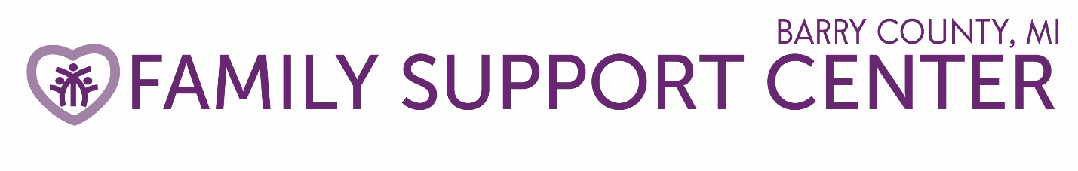

ANNUAL REPORT

231 S Broadway, Hastings MI 49058

Phone: 269-945-5439 Fax: 269-945-6312

Email: Karen@familysupportbarry.com

Website: www.familysupportbarry.com

The Family Support Center’s mission is to prevent all forms of child abuse and neglect through awareness, advocacy and education.

Dear Friends,

Our annual report gives us the opportunity to look back and be thankful for all the families we have assisted in this last year. The past fiscal year was filled with wonderful opportunities and many challenges. Some of the highlights were:

- Approximately 586 Barry County families were investigated for suspected child abuse or neglect, 25% were confirmed equaling 148 confirmations.
- Our Parent Educator assisted 19 families in achieving positive parenting skills impacting 33 children.
- Our Kinship Support Program helped 31 families caring for 57 family member’s children.
- The parents of 298 new baby’s parents received safe sleep information as well as what to do with a crying baby and “Your Baby’s First Year” book. 183 families received the “Period of Purple Crying” information, preventing Shaken Baby Syndrome.
- 141 adults and 79 children participated in our Family Workshop Series with free pizza dinner and child care activities. 70 volunteers assisted in the activities.
- Safe Sleep CRIB Program placed 21 cribs, 14 toddler beds, 1 pack-n-play and 28 mattresses with families to ensure infants in Barry County sleep safely.
- More than 351 students received Baby Basics and now better understand the Prevention of Shaken Baby Syndrome.

The following is an overview of Family Support Center income and expenses for the fiscal year ended December 31, 2017.

Total Support & Revenue: $114,602.00
Program Expenses: 91,639.00
General and administration Expenses: 12,841.00
$104,489.00
Increase (Decrease) in Cash: 10,122.00
Beginning Cash: 37,109.00
Ending Cash: $47,231.00

Board of Directors
Sheryl Overmire, President
Gina McMahon, Secretary
Sharon Barry, Treasurer
Dave Banister, Board Member
Laura Brandt, Board Member
Carol Dwyer, Board Member
Jennifer Eastman, Board Member
Matt Goebel, Board Member
Rich Thiemkey, Board Member
Laurel McCamman, Board Member
Marci McCoy, Board Member
Julie Pratt, Board Member
Jeff Pratt, Board Member
Amy Young, Board Member
Executive Director: Karen Jousma
Parent Educator/Kinship Coordinator: Mary Chapman
Administrative Assistant: Amanda Hoeksma
Media, Marketing & PR: Vera Yenger

A copy of the Family Support Center current 990 is available upon request.
www.guidestar.com

The Family Support Center of Barry County is tax-exempt under 501(c)(3) of the Internal Revenue Code. Donations are tax-deductible to the extent allowed by law.

