Child and Adolescent Development Resource Guide

Websites
- Milestone checklists from the CDC for ages 2 months-5 years: https://www.cdc.gov/ncbddd/actearly/index.html
- Milestones in action (pictures and videos) from the CDC for ages 2 months-5 years: https://www.cdc.gov/ncbddd/actearly/milestones/milestones-in-action.html
- Healthy Children Ages and Stages https://www.healthychildren.org/English/ages-stages
- Child Mind Institute https://childmind.org/
- Early On (developmental support for children in Michigan) https://www.1800earlyon.org/
- Understood (for learning and attention issues) https://www.understood.org/en

Apps
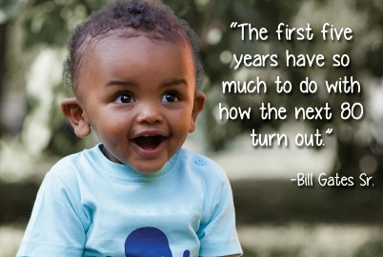
CDC’s Milestone Tracker – ages 2 months-5 years
Child Health Tracker – ages 0-18 years
Bright Futures Visit Planner – ages 0-18 years
Playfully – ages 0-3 years
MoodTools – Depression tools

