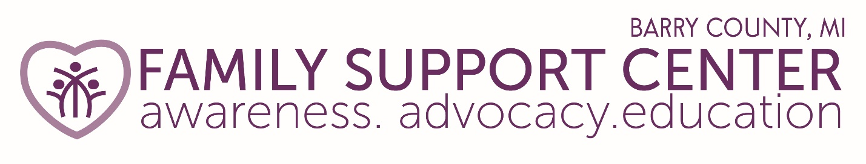

Mission: Eliminate and prevent all forms of child abuse and neglect through awareness, advocacy and education.

NEWSLETTER SUMMER 2020
In spite of COVID-19, the Family Support Center of Barry County continues to serve the communities in Barry County. Our staff has been working remotely to ensure programming is still available for clients. Although we are operating differently and some things have changed, we still have the same mission and commitment to provide support for you and your family. In a few weeks, we will open our office for appointment only visits. You can be assured that we are committed to adhering to all cleanliness and PPE guidelines to provide a safe and healthy environment. Should you visit us when we reopen, please be prepared to wear a mask, have your temperature checked, and answer some health questions prior to entering our office. In the meantime, here’s some information regarding some of our programs and how you can continue to receive the services we offer.
Family and Parent Education Programs continue via Zoom and Skype. Contact our office at 269-945-5439 or email jennifer@familysupportbarry.com. We accept referrals from other agencies as well as self-referrals. See the Referrals tab at the top right on our website home page. www.familysupportbarry.com
Our Safe Sleeping Environment CRIB Program provides a crib, toddler bed or pack ‘n play, mattress, crib sheets and parent education materials for those who need a safe sleeping environment for their child. Contact our office at 269-945-5439 or email karen@familysupportbarry.com to make a request. We accept referrals from other agencies as well as self-referrals.
We are very excited as we finalize our plans to launch an improved Kinship Care Program for adults raising, nurturing and protecting family member’s children, this coming fall. If you are a grandparent, aunt, uncle, sister, brother or other relative looking for support as you fulfill this role, please contact us about our many services. Our Parent Educator and Kinship Coordinator, Jennifer continues to provide services so reach out to her at 269-945-5439 or email Jennifer@familysupportbarry.com.
Other group training can be delivered either virtually, through Zoom, or in person with social distancing and masks. If you have interest in Mandated Reporter Training or Sexual Abuse Prevention Training, please email karen@familysupportbarry.com.
Through our Diaper Depot Program, we continue to provide diapers and other changing needs to five baby pantries throughout Barry County. If you need diapers, we can provide you with contact information for the pantry closest to you. If you would like to volunteer or donate to this program, we welcome your support! Please email karen@familysupportbarry.com.

CURRENT AND UPCOMING EVENTS

Join us for the next Community Breakfast on Wednesday, August 19 from 8:00 AM – 9:00 AM with location or Zoom meeting yet to be determined. We will cover two important topics at the breakfast – CASA for Kids, Inc. as well as an update on the Family Promise of Barry County. This is a great time to hear what is available in our community for children and families. Like and follow our Facebook page and our website for the announcement as to whether this will be an in-person meeting or held via Zoom technology or email linda@familysupportbarry.com.

Board Meetings - The next Family Support Center of Barry County Board meeting will be held on July 30 at noon. If you are interested in attending, please email linda@familysupportbarry.com for additional information.

Annual Family Support Center Golf Outing – We are very excited to move forward in partnership with the Hastings Elk’s Lodge #1965 to hold our 19th Annual Golf Outing on Saturday, August 8 at the Legacy at Hastings. There is a shotgun start at 8:30AM and lunch will be provided at the “Outback”. Information can be found on our website at www.familysupportbarry.com. We hope you can be a sponsor or join us for a round of golf.

Trauma Informed Community – Check out and Like a new Facebook page “Barry County Trauma Informed Community” for tips on handling COVID-19 challenges.

Best wishes – We hope you and your family can get outside and enjoy the summer weather and soon we will be able to move beyond the Coronavirus. Be safe and please know we are here to help.

Linda Maupin Karen Jousma Jennifer Jarman
Executive Director Program Director Family Educator/Kinship Coordinator

July
Spend some time celebrating July!
National Ice Cream Month
National Picnic Month
National Fishing Month
National Parent’s Day – July 28th

August
Have some fun in August!
American Artist Appreciation Month
National Immunization Awareness Month
International Cat Day – August 8th
International Youth Day – August 12th
National Banana Split Day – August 25th
National Dog Day – August 26th

